**PRESS RELEASE**

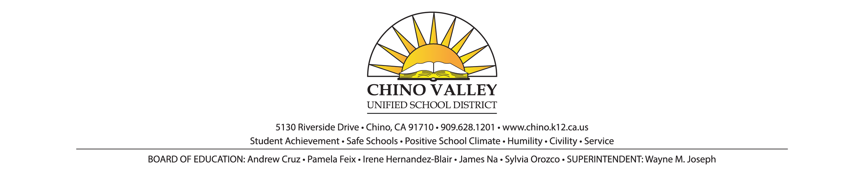**FOR IMMEDIATE RELEASE**

January 24, 2018

**CONTACT**: Imee Perius, Director of Communications

(909) 628-1201 ext. 1616, *OR*

Brenda Dunkle, Multi Media Communications Specialist

(909) 628-1201 ext. 1617

**Chino Valley Unified School District kindergarten registration**

**for the 2018/2019 school year beginning soon**

Chino, CA. -- Kindergarten registration for the 2018/2019 school year will begin as early as the week of January 29, 2018 for a few Chino Valley Unified School District elementary schools and will continue for all schools throughout the spring. Eleven elementary schools will offer a Pilot Online Registration system for parents. Please see the attached schedule for school enrollment start dates and registration options.

Parents and guardians registering their child for kindergarten must provide their child’s school with proof of the student’s age, proof of residency and immunization records. Proof of age may include: birth certificate, baptismal certificate, or any other appropriate means of proving the age of the child. A child who will reach the age of five (5) on or before September 1 of the school year is eligible for enrollment in kindergarten at the beginning of the school year or at any later time in the same school year. The previous stipulation applies to registration for schools with a year-round calendar. That is, if a child will turn five (5) years old after the start of year-round school, but before September 1 of that year, they may register for kindergarten at the year-round school.

Reasonable evidence of residency may be established by documentation, including, but not limited to any of the following: property tax payment receipts, rent payment receipts, utility service payment receipts, or a declaration of residency executed by the parent or guardian of the pupil. **A driver’s license does not qualify for proof of residency.**

Students entering a District school or child care and development program, or transferring between school campuses, shall present an immunization record which shows at least the month and year of each immunization, in accordance with law. Students shall be excluded from school or exempted from immunization requirements only as allowed by law.

Board of Education policy requires immunizations. The following immunizations are required for entering kindergarten students: Polio *(4 doses),* Diphtheria, Tetanus, and Pertussis *(5 doses),* Measles, Mumps, Rubella (MMR) *(2 doses), H*epatitis B *(3 doses),* Varicella *(1 dose).*

###